**Sales Design Plan**

**Page Load**

--SalesController—-

**Category Selection (<asp:ListView>)**

[DataObjectMethod(DataObjectMethodType.Select)]

Public List<CategoryPart> getCategories()

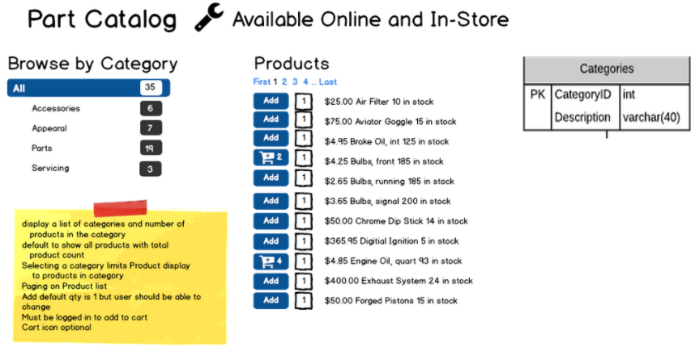

**Product selection (<asp:ListView>)**

Public List<CategoryPar> getProducts(int categoryID)

**Add to cart Button(<asp:Button>)**

public void AddToCart(IPrincipal user, int partId, int quantity)

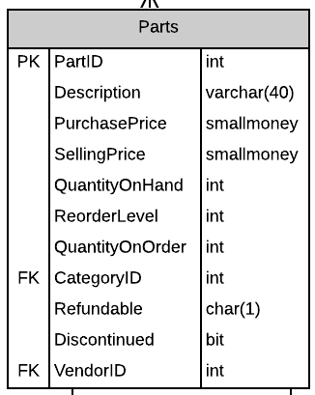

**Shopping cart navigation (<asp:Bulletedlist>)**

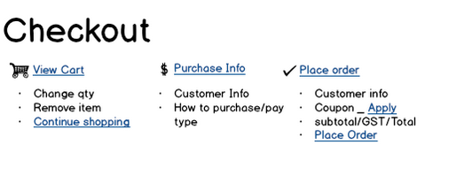

**ShopingCart Phase 1**

**Products in cart (<asp:ListView>)**

[DataObjectMethod(DataObjectMethodType.Select)]

public List<ProductInCart> ListProductsInCart(int shoppingCartId)

**Update Quantity Button(<asp:Button>)**

[DataObjectMethod(DataObjectMethodType.Update)]

public void UpdateProductsQty(int shoppingCartItemId,int quantity)

**Delete Button(<asp:Button>)**

[DataObjectMethod(DataObjectMethodType.Delete)]

public void DeleteProductFromCart(int shoppingCartItemId)

**Product total and Date(<asp:ListView>)**

public DateTime UpdateSaleDate(int shoppingCartId)

public money setTotal(int shoppingCartId)

**Continue (<asp:Button>)**

‘Continue’ navigates to next page (Phase 2)

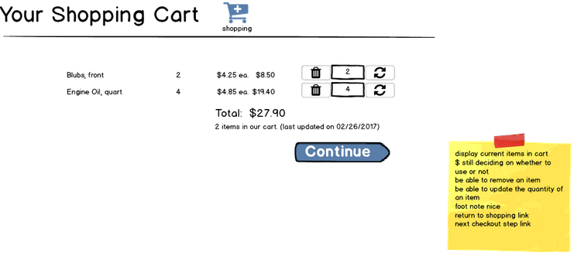

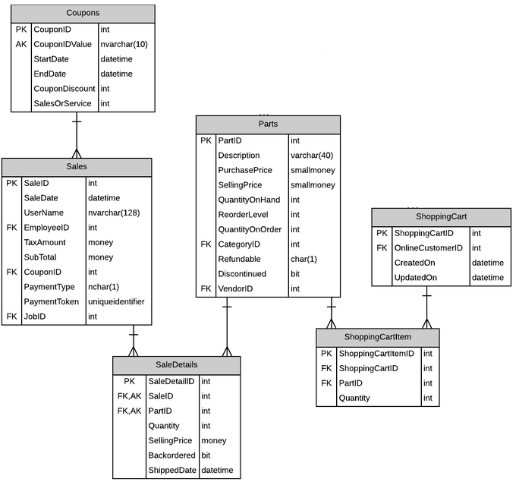

**Shopping Phase 2 – adding only html content**

**Billing Details (<asp:TextBox>) Read Only**

**Place Order (<asp:Button>)**

‘Continue’ navigates to next page (Phase 3)

**Place Order (<asp:Button>)**

‘Back’ navigates to (Phase 1)

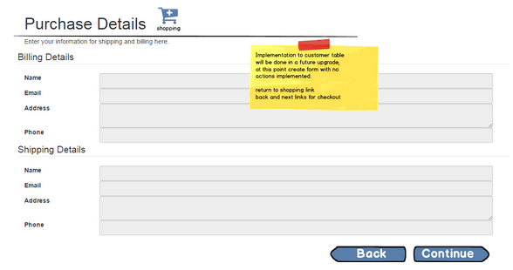

**ShopingCart Phase 3**

**Products in cart (<asp:ListView>)**

[DataObjectMethod(DataObjectMethodType.Select)]

public List<ProductInCart> ListProductsInCart(int shoppingCartId)

public DateTime UpdateSaleDate(int shoppingCartId)

public void CalculateAllTotals(int shoppingCartId)

**CouponDownList (<asp:DropDownList>)**

[DataObjectMethod(DataObjectMethodType.Select)]

public List<CouponKey> GetCoupons()

**Refresh Button (<asp:Button>)**

public void UpdateSaleTotalWithCoupon(int couponID)

**Place Order (<asp:Button>)**

public void PlaceOrder(SaleSummary Order)

